- We forecast UK GDP growth will average 1.5% a year over the medium-term. Though strong inward migration will continue to provide support, the UK's ageing population means the economy must rely less on increasing labour supply as a growth driver and more on productivity gains. We're optimistic that it can improve productivity growth, but it's not guaranteed.
- The new population projections from the Office for National Statistics look too high to us, considering the importance of temporary factors in driving recent high immigration and policy changes aimed at cutting legal immigration. Our forecasts use the ONS's low migration scenario.
- Increasing the state pension age has been a key spur to strong labour supply growth since 2010. But the retirement age will rise by just two more years before 2050. Ageing will increasingly weigh on workforce growth because older people participate less.
- We're sceptical that productivity growth will recover as strongly as the Office for Budget Responsibility anticipates in the next few years. Still, productivity should gradually strengthen, based on the longer-term potential boosts from AI and investment in technologies to support the energy transition towards net zero.
The Office for National Statistics recently published a new set of population projections for the UK – the first since the 2021 census – and the Office for Budget Responsibility is due to present its new economic forecasts shortly. So, it's a good time for us to revisit our medium-term projections for economic growth.
We think the severe disruption caused by the pandemic during 2020-2021 means this decade will be the weakest for overall GDP growth since the 1920s. But, using our production function framework for estimating potential output (see Box for details), we expect growth in the second half of the decade to be similar to that seen in the 2010s (Chart 1). The similarity between the overall growth rates masks a shift in composition, however, with the economy set to become less reliant on strong growth in labour supply and more dependent on reversing the recent poor productivity performance. This transition will not be easy.
Chart 1: We expect potential output growth to settle at 1.5% a year in the medium-term
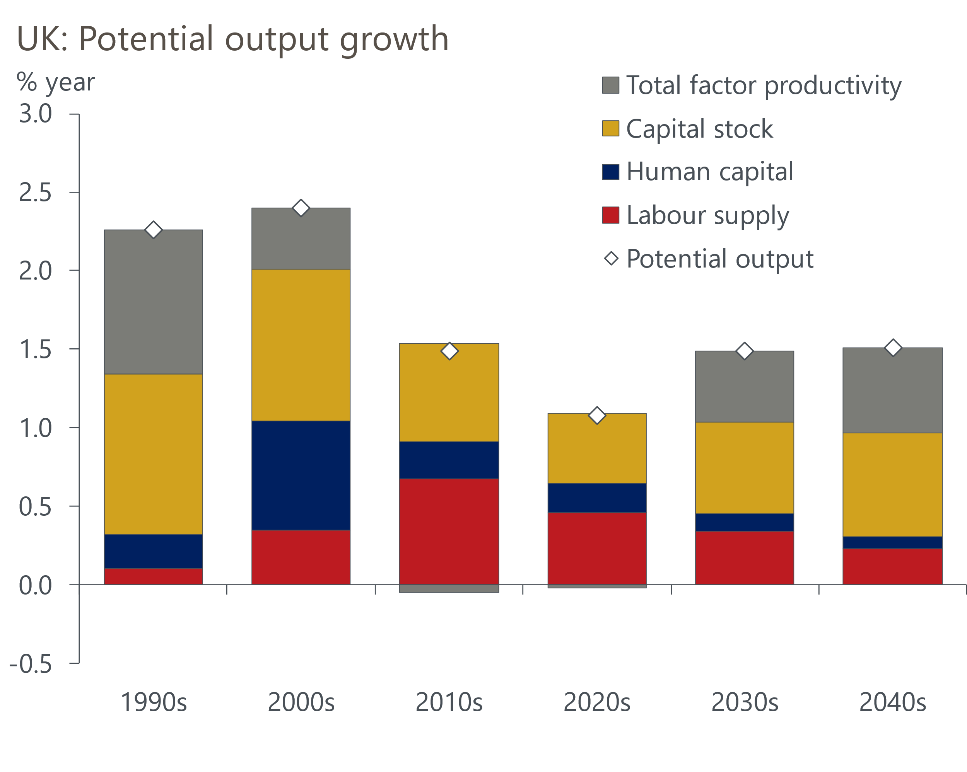
Source: Oxford Economics

New ONS population projections look too high
Official UK population estimates and projections have been in a state of flux for most of the period since the start of the pandemic, initially due to problems measuring migration and then delays producing census-consistent historical estimates. The historical picture remains incomplete because Scotland hasn't published its census-consistent data for 2011-2022. But the ONS has pressed ahead and published interim UK projections based on the mid-2021 data.
The new projections put total population 4.4mn (6%) higher in 2050 than the previous vintage, mainly due to a much higher assumption for net inward migration. The ONS based its long-term (post-2028) assumption on the average migration flows of the past ten years, applying a linear interpolation from the provisional 2023 outturn to produce its assumptions for the next five years.
This method results in an assumption of 315,000 net inflows a year, which we think is too high. The ten-year average includes two years of exceptionally high inflows, in part due to special factors – visa schemes for migrants from Ukraine and Hong Kong, and the post-pandemic recovery in student inflows – that are unlikely to be repeated. In the ten years before the pandemic, net inflows averaged 241,000 a year and only one of those years saw net inflows as high as the ONS's assumption.
What's more, the government has announced a series of measures aimed at cutting legal immigration, including limiting the ability of foreign students to bring dependents to the UK, raising the minimum salary for a skilled worker visa, and increasing the minimum income required to qualify for a spousal visa.
Therefore, we think it more appropriate to adopt as our baseline assumption the ONS's low migration variant, which assumes net inflows of 253,000 a year over the medium-term (Chart 2). But this is still 48,000 a year higher than the central assumption used in the ONS's 2020-based projections.
Chart 2: We think the ONS' low migration variant is the most realistic assumption
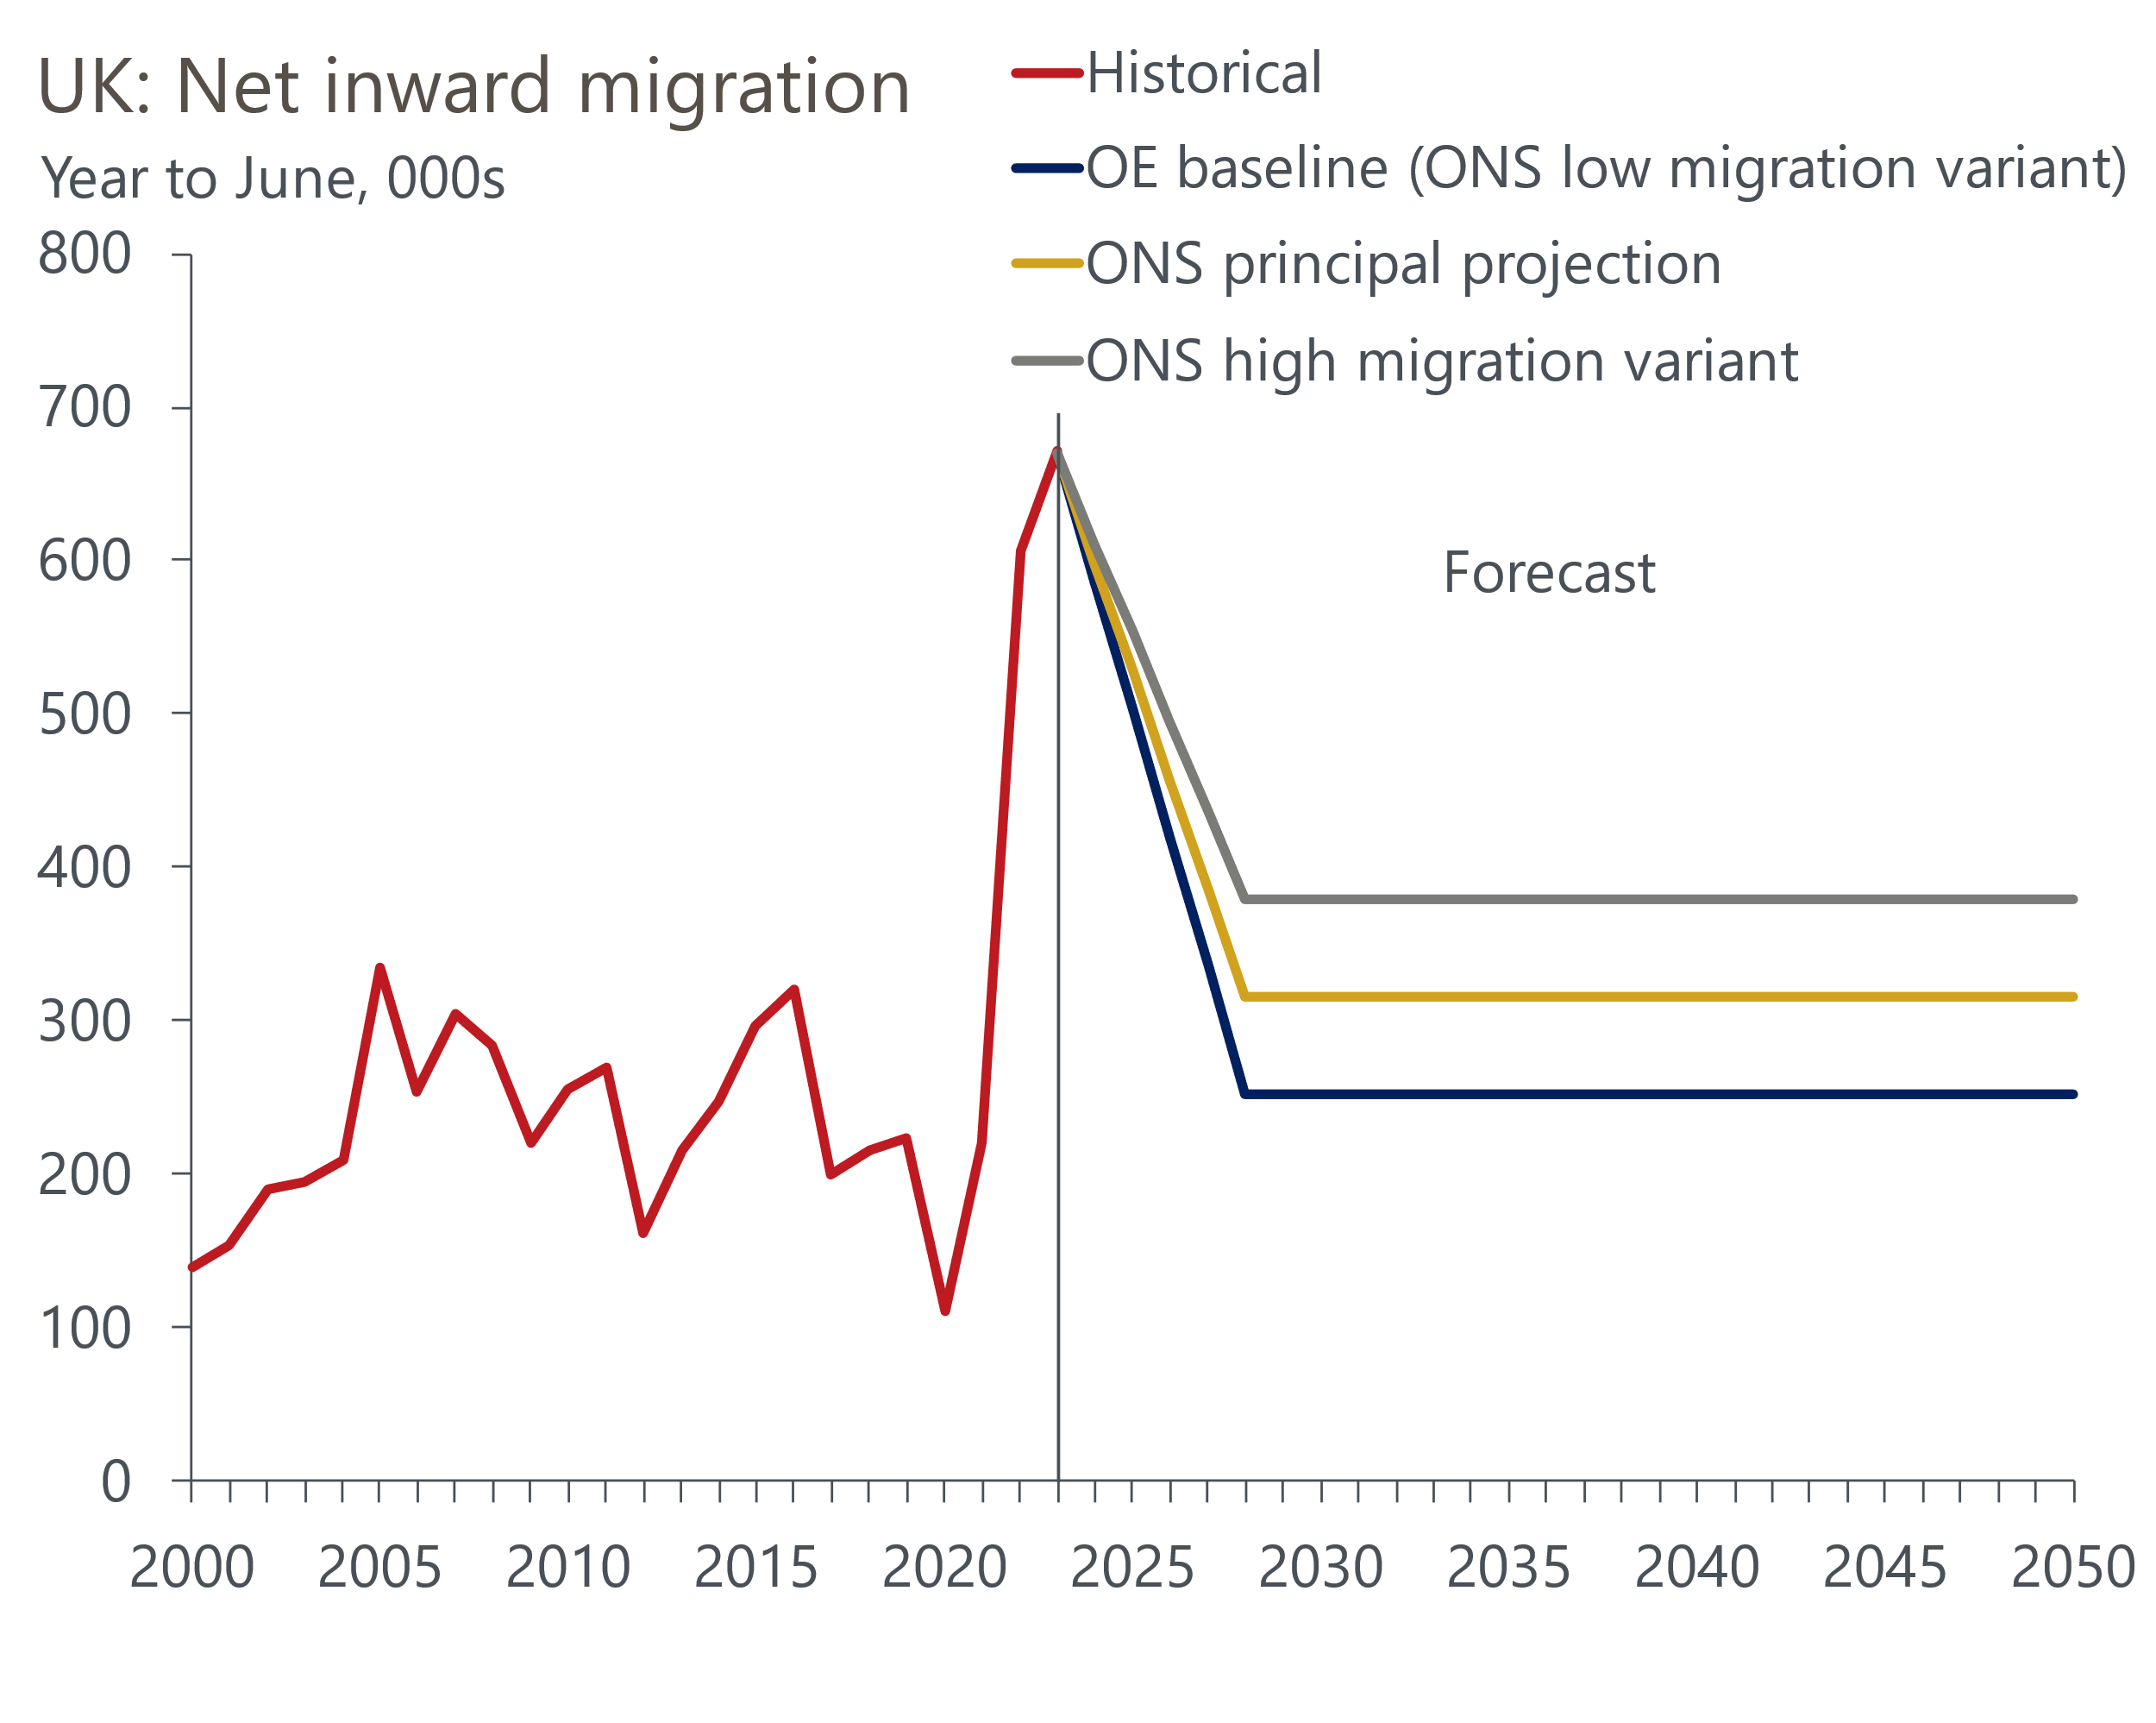
Sources: Oxford Economics, ONS
Meanwhile, other demographic factors are likely to become less supportive. The UK population is ageing – 17% of the population were over 65 in 2010, but this has now increased to 19% and the ONS projects it will rise to 23% in 2050. Participation tends to drop off steeply moving up the age distribution – activity rates for males and females aged 25 to 49 are above 90% and 80% respectively, but both drop by around 15ppts for the 50-64 cohort. And of those aged over 65, just 15% of males and 8% of females are currently classed as economically active.
Increased longevity is one of the factors behind the rising share of older people, and that has been recognised in increases in the state pension age – from 60 in 2010 to 66 now for females, and from 65 to 66 for males. The working age population today is just over 2mn larger than it would have been had the state pension ages remained at their 2010 levels. There has also been a sharp rise in participation around the state pension age. Indeed, the number of people employed who are over 50 has increased by 2.9mn since the state pension age started rising – more than two-thirds of the increase in total employment (Chart 3).
Chart 3: Older workers are responsible for the bulk of the rise in employment since 2009
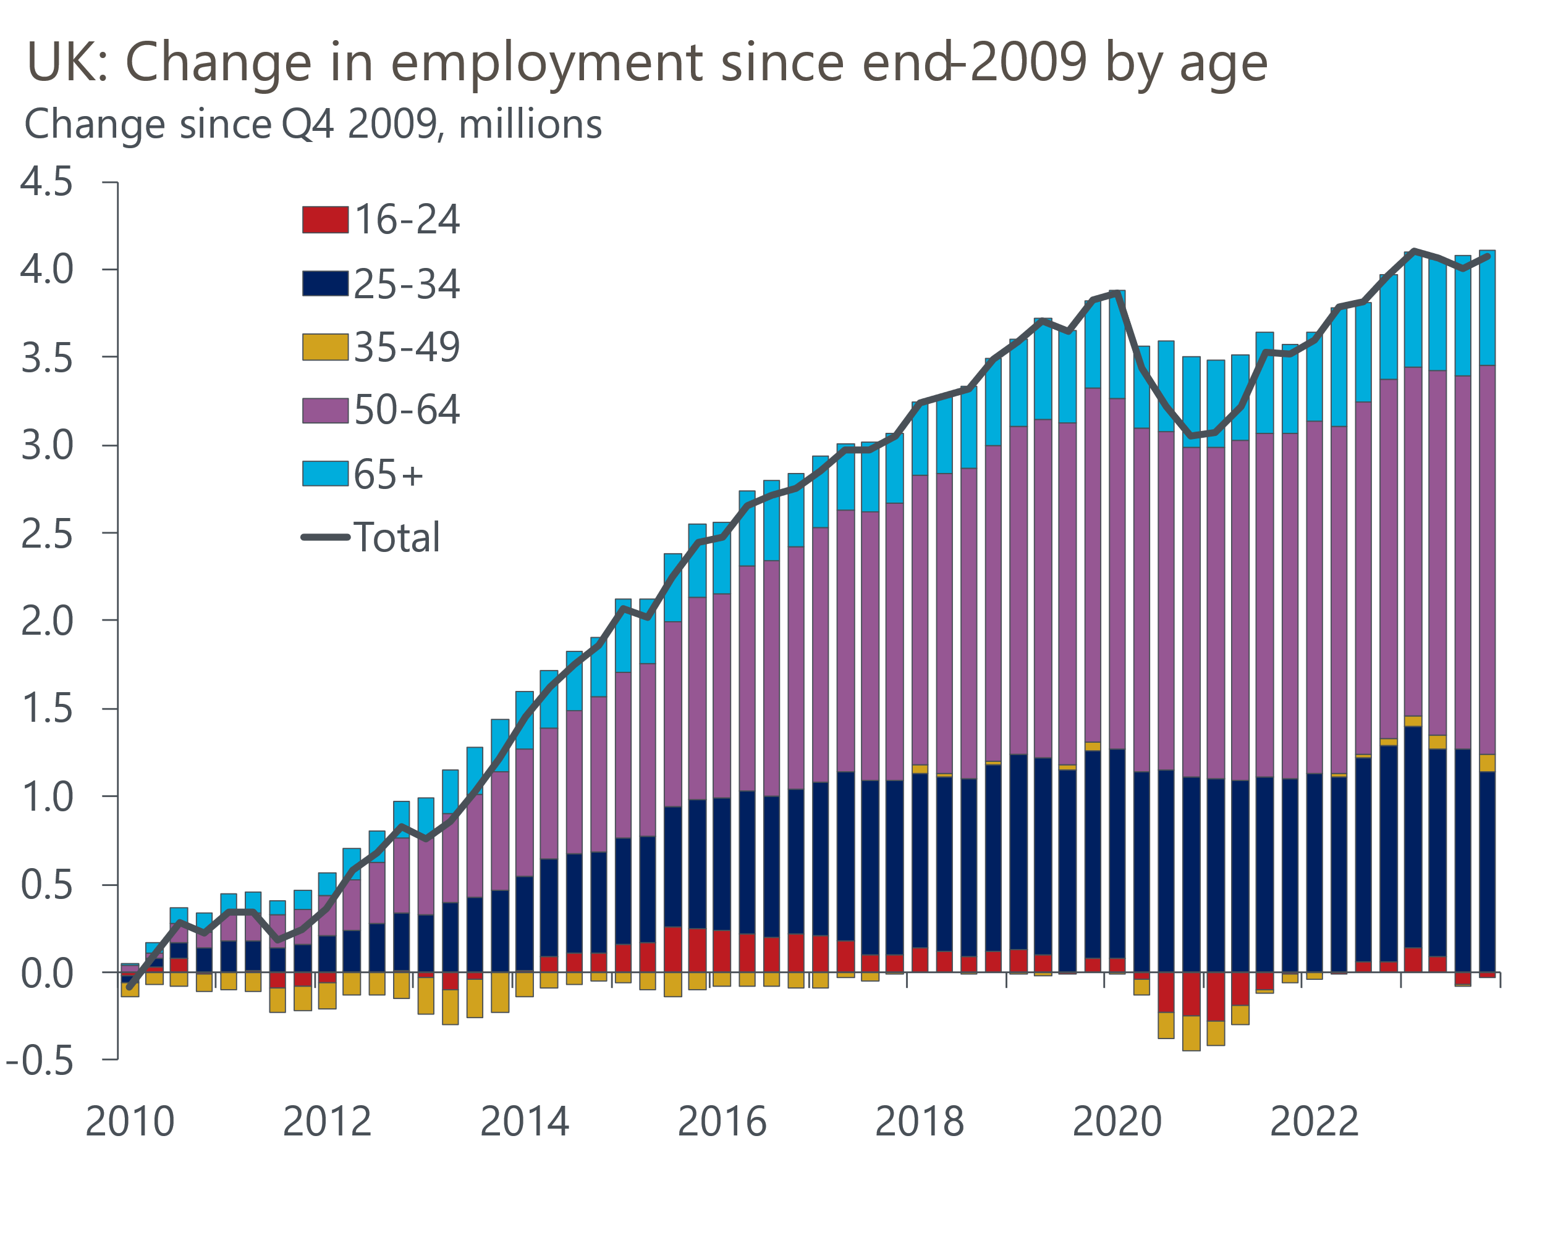
Source: Haver Analytics
But under current plans the support from a rising state pension age will start to fade. Just two more single year increases have been legislated for: from 66 to 67 between 2026 and 2028, and from 67 to 68 between 2046 and 2048. This combination of population ageing and a relatively small increase in the state pension age will mitigate the boost to labour supply from migration. Working age population growth has averaged 1% a year over the past decade, but we forecast it will slow to 0.6% a year over the next ten years, and then just 0.1% a year in the following decade, when there is no increase in the state pension age planned (Chart 4).
Chart 4: Growth in working age population is set to slow sharply
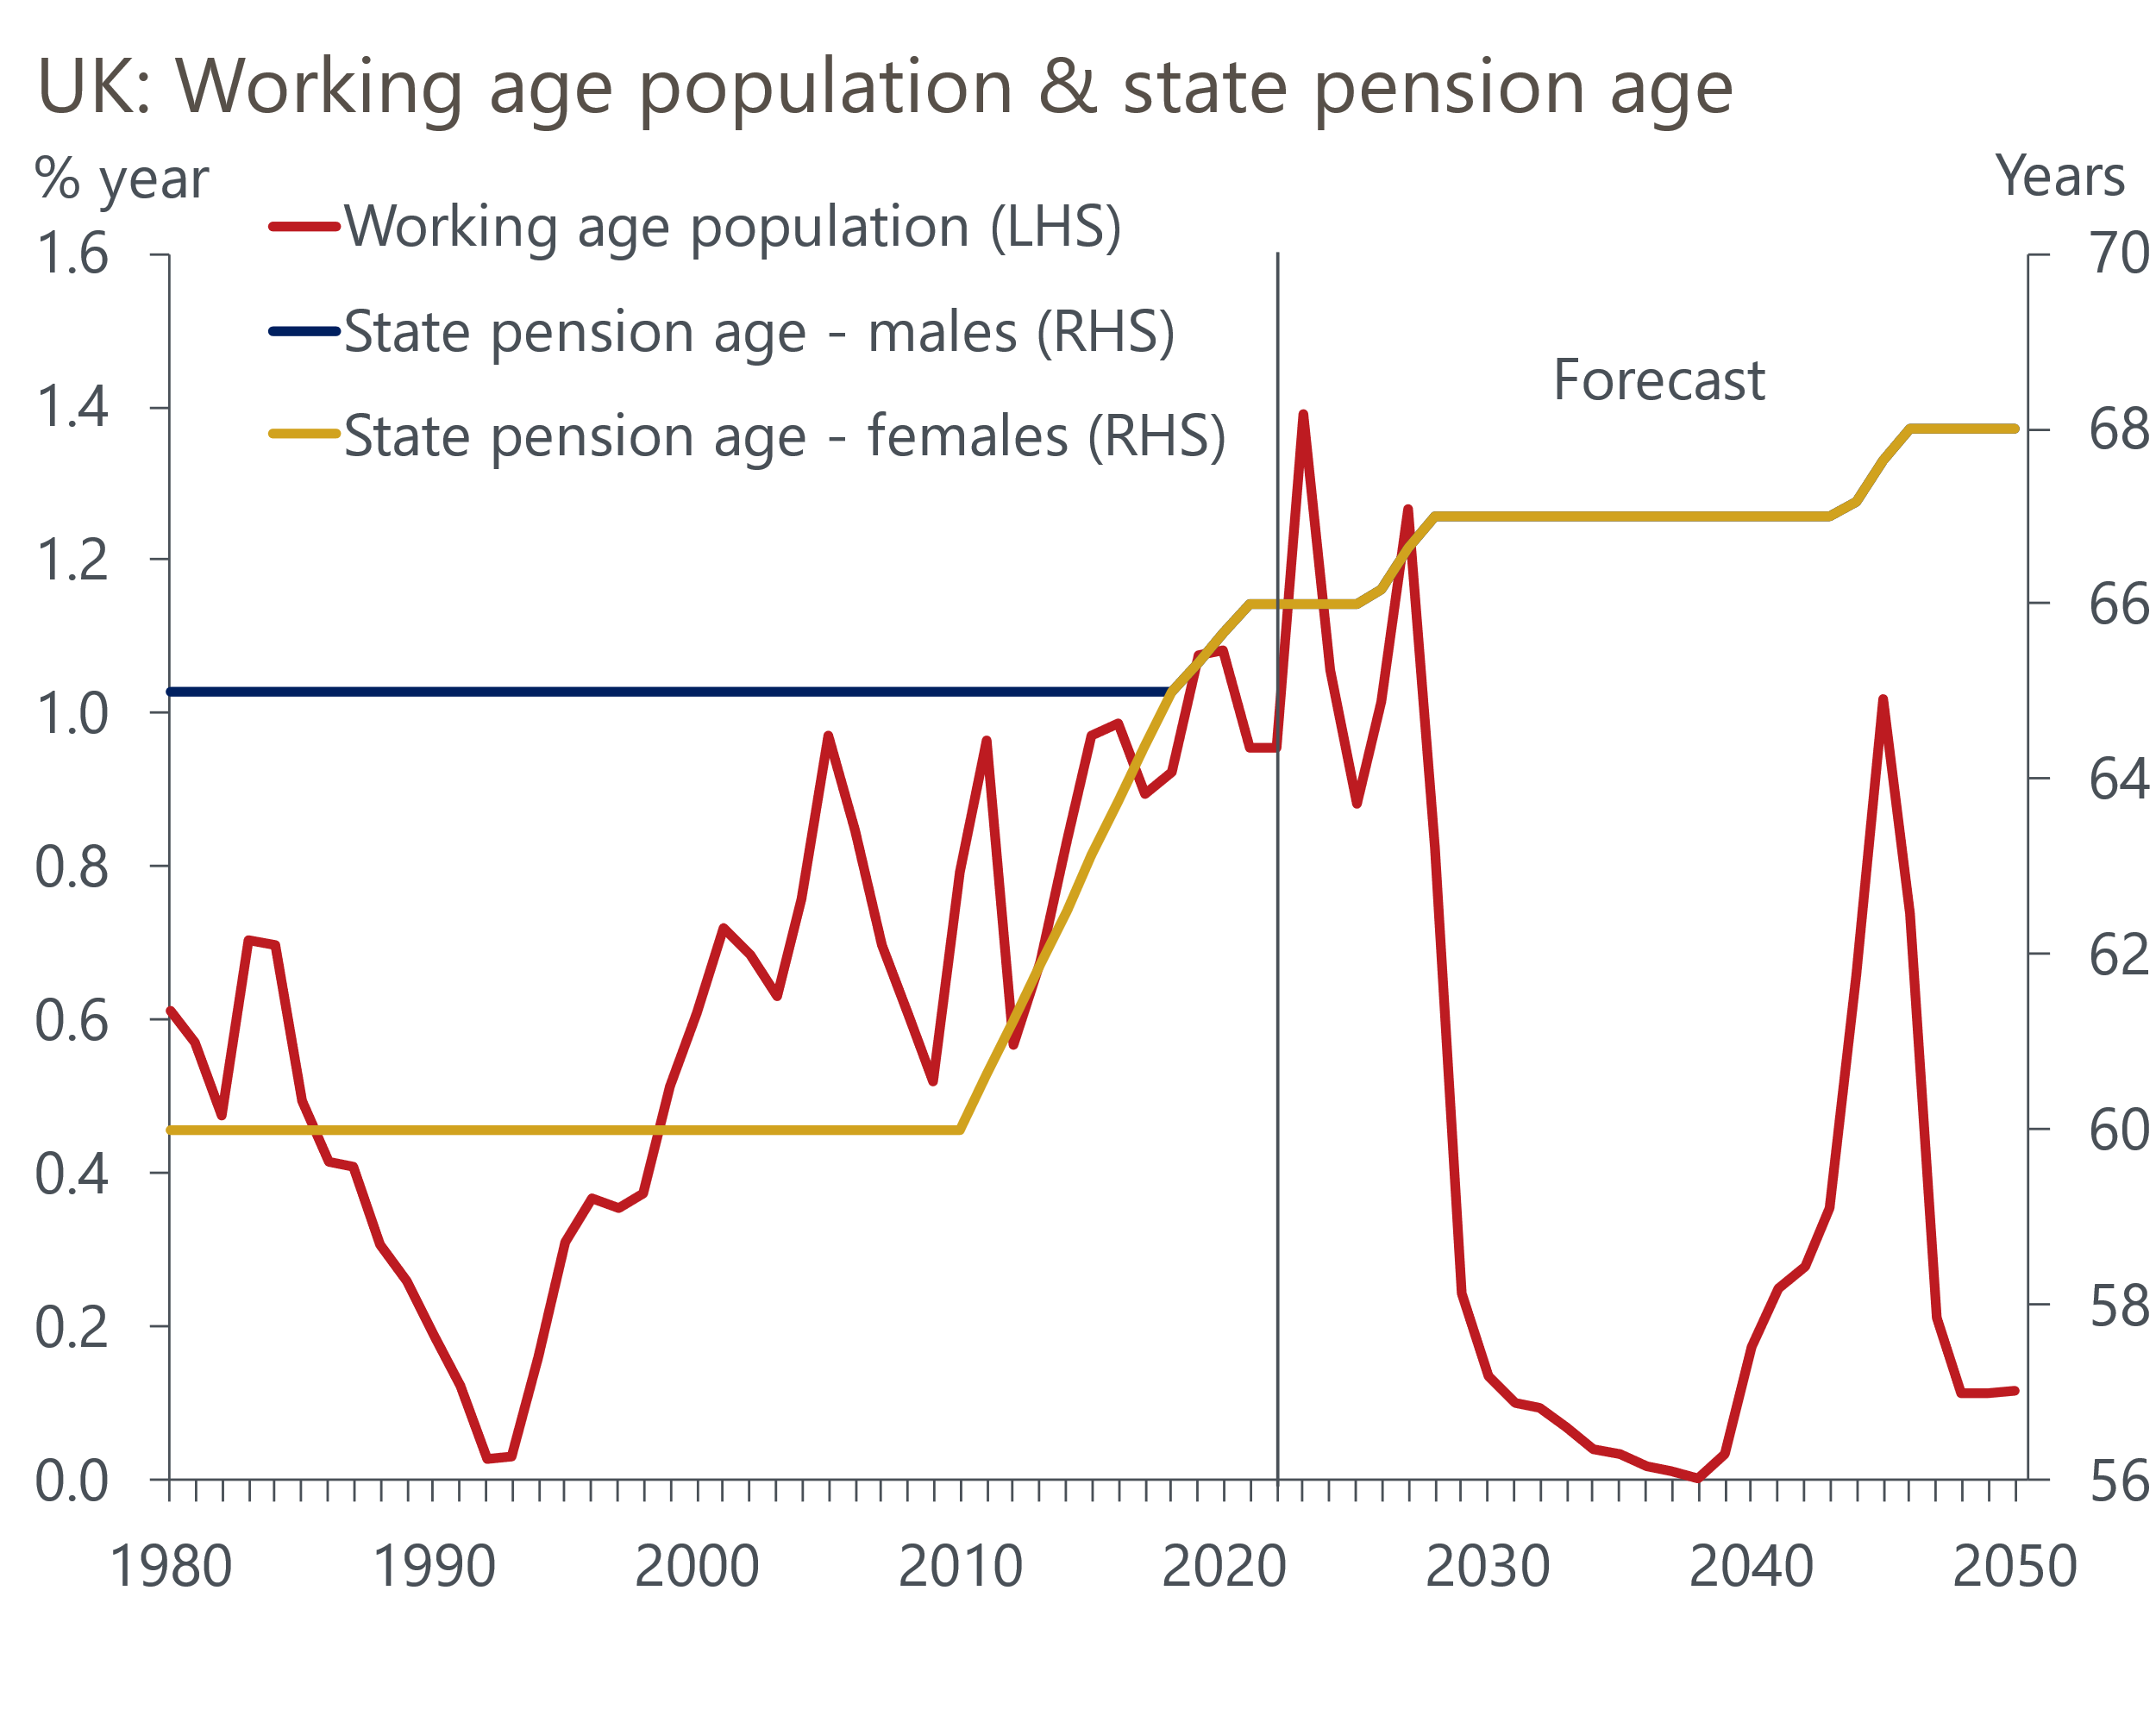
Sources: Oxford Economics, ONS

Rising sickness continues to weigh on participation
Ageing is also one of the factors underpinning the sharp rise in inactivity due to long-term sickness. The latest data shows 2.8mn people aged between 16-64 unable to participate in the labour market for this reason. This represents 30% of those who are inactive, comfortably the highest share since this data was first published in the early 1990s (Chart 5).
Chart 5: Inactivity due to long-term sickness has risen sharply since the start of the pandemic
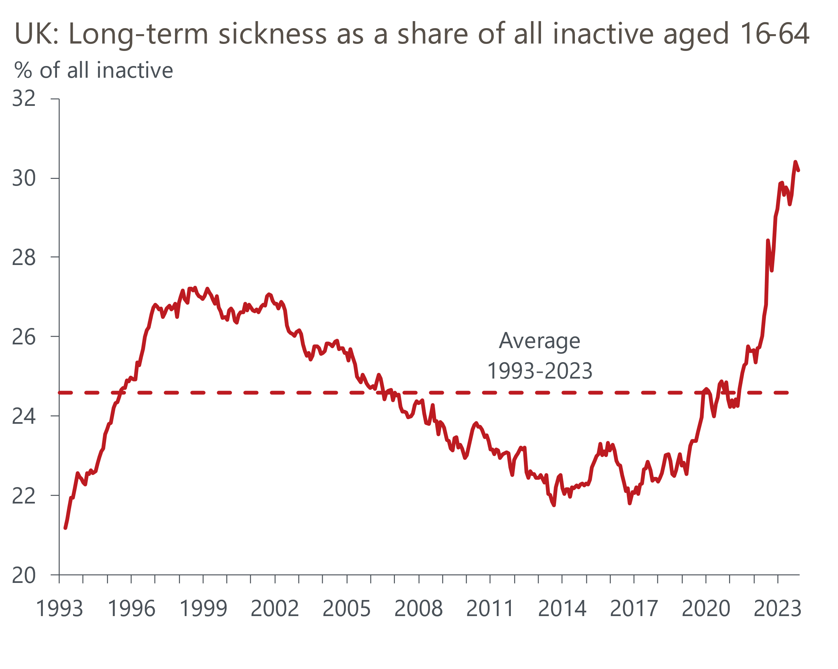
Source: Haver Analytics
The increase since the start of the pandemic has been particularly marked, and only some of it is due to long Covid. Other factors include worsening mental health and lengthening waiting lists for treatment via the National Health Service. An ONS deep dive into the link between inactivity and ill health published last year demonstrates the scale of the challenge in turning this around. A large – and growing – share of this group report that more than one health condition is acting as a barrier to their return to the labour market.
Furthermore, the problems extend beyond those who are currently inactive. The number of people of working age reporting one or two health conditions has risen from 8.5mn in 2016 to 10.6mn in 2023, suggesting there's a sizeable group who are at risk of becoming inactive if their conditions worsen. But on the flip side, given how extreme the recent increase in long-term sickness has been, there is a good chance that some of the increase could be reversed if the government is able to make headway in reducing NHS waiting lists.
Combining our assumptions for demographics and participation, we expect the contribution of growth in labour supply to potential output to gradually slow, from 0.7ppts a year in the 2010s to 0.5ppts in the current decade and eventually falling to 0.2ppts in the 2040s.

Prospects for productivity growth remain subdued
With the contribution of expanding labour supply likely to drop, this puts a bigger onus on productivity to drive potential output growth. But the UK's productivity performance over the past fifteen years has been dismal – output per hour worked has averaged just 0.4% a year since the global financial crisis, compared with 2.2% a year in the previous 35 years (Chart 6).
Chart 6: The UK's productivity performance since the global financial crisis has been dismal
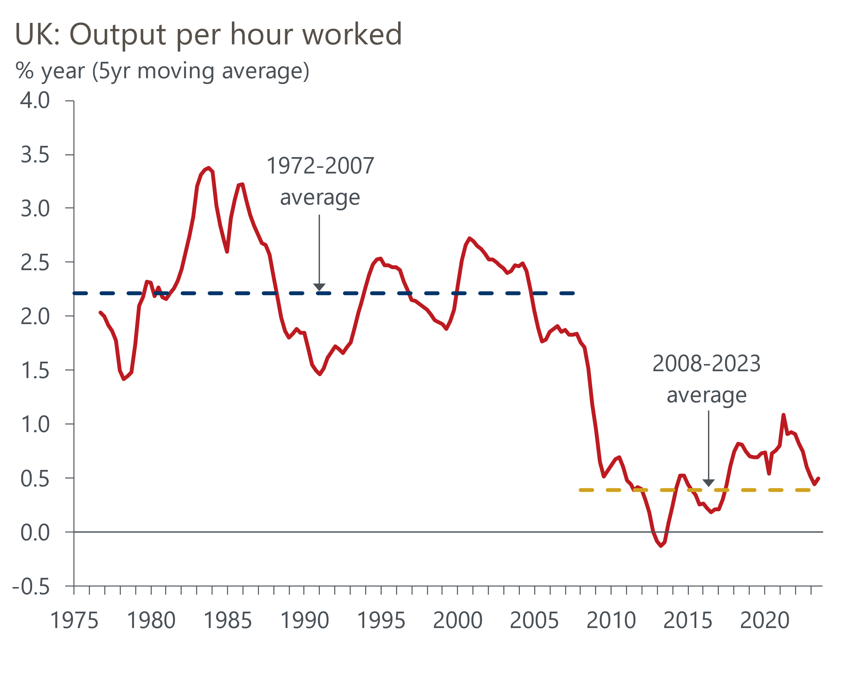
Sources: Oxford Economics, Haver Analytics
We analysed the UK's poor productivity performance in a recent report, finding that the weakness was evident across most sectors of the economy. We argued this reflected a variety of factors including the repercussions of the financial crisis, tight fiscal policy stifling demand, low levels of public investment, Brexit, and a trend towards political short-termism.
Though the legacy of the financial crisis has now faded, many of the other factors are likely to remain drags on productivity growth in the future. Tight fiscal policy and low levels of public investment are likely to remain particularly powerful headwinds over the next five years, with current government plans implying a significant tightening of policy after the election this year, and a potential Labour government unlikely to have much room for manoeuvre given its own pledges.
Still, we have identified two developments that could potentially drive stronger productivity growth: artificial intelligence and investment in technologies to tackle climate change.
Our analysis shows that some of the periods of rapid productivity growth since the 19th century have been closely linked to the rise of new technologies, such as railways, electric power, and computers. Given AI is a general-purpose technology with potentially large spillovers, it too could have a large impact. However, not all new technologies have yielded large productivity gains, while those that have provided a big boost have only done so many years after the technology was invented.
Our consultancy team has identified a large global opportunity from the transition to a greener global economy. The development of renewable power generation and electric vehicle manufacturing offer particularly large potential gains, with clean energy manufacturing, biofuels, and green finance also offering opportunities. Government support will be particularly crucial to positioning the UK as a global leader in this field, but both main political parties have recently scaled back their commitments in this area. The government has watered down some of its net zero policies, while Labour has abandoned its flagship policy of investing £28bn a year in green policies because it is unwilling to commit to higher government borrowing to finance it.
So while we are optimistic that both AI and climate change technologies will offer support to productivity growth, we're cautious about how large those gains will be and expect them to emerge slowly.

We expect potential output growth to settle at around 1.5% a year
Bringing the various elements of the forecast together, we expect potential output growth of around 1.5% a year for the rest of this decade. This is similar to the OBR's November 2023 projection, though the OBR's forecast pre-dates the new, higher, population projections and relies on a stronger pickup in productivity growth (Chart 7). Though the Bank of England revised up its forecast for potential supply in February's Monetary Policy Report, it's latest assumptions are still some way below ours. However, the gap is likely to narrow when the BoE incorporates the new population projections.
Chart 7: Our projections are similar to the OBR's latest forecast
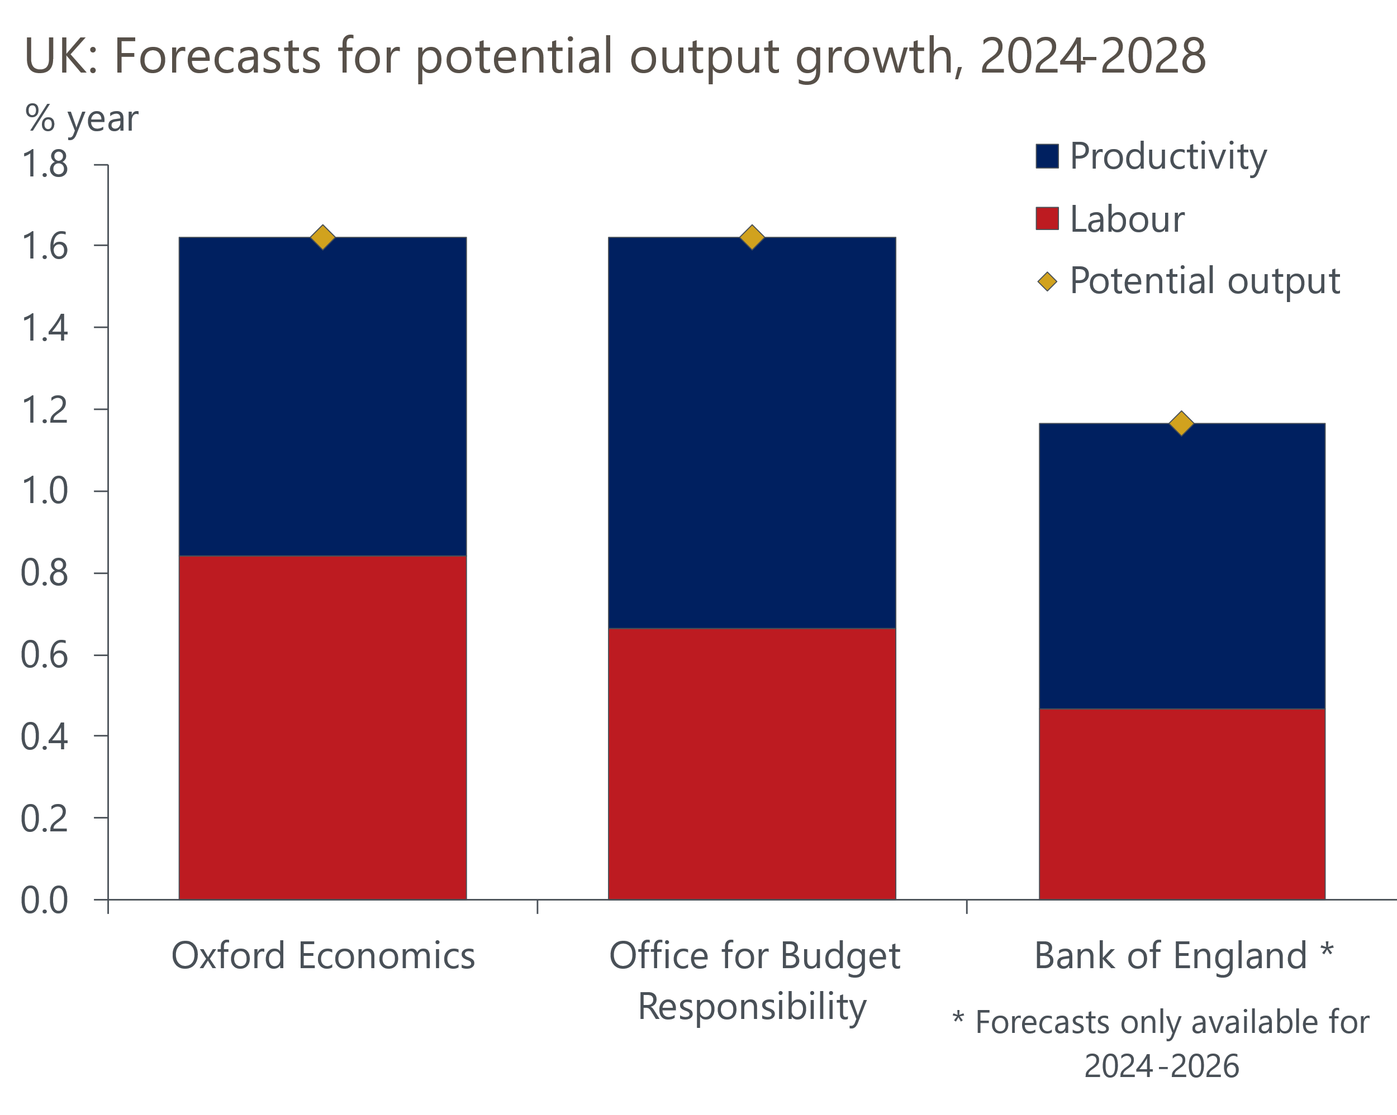
Sources: Oxford Economics, OBR, Bank of England
Where we differ markedly from the OBR is on the extent to which productivity growth will accelerate in the 2030s and 2040s. Even before the OBR has had the opportunity to incorporate the new population projections, its forecast for 2050 puts the level of GDP 5ppts higher than ours (Chart 8). The OBR expects the drag from Brexit-related factors will gradually fade, and that productivity growth will move closer to long-run historical norms than the experience of the past 15 years. This assumption is not implausible, particularly if the gains from AI adoption and investment in climate change technologies begin to emerge quickly. But it looks optimistic in the context of the much weaker productivity growth of the past 15 years.
Chart 8: Our long-term growth forecast is more cautious than the OBR's
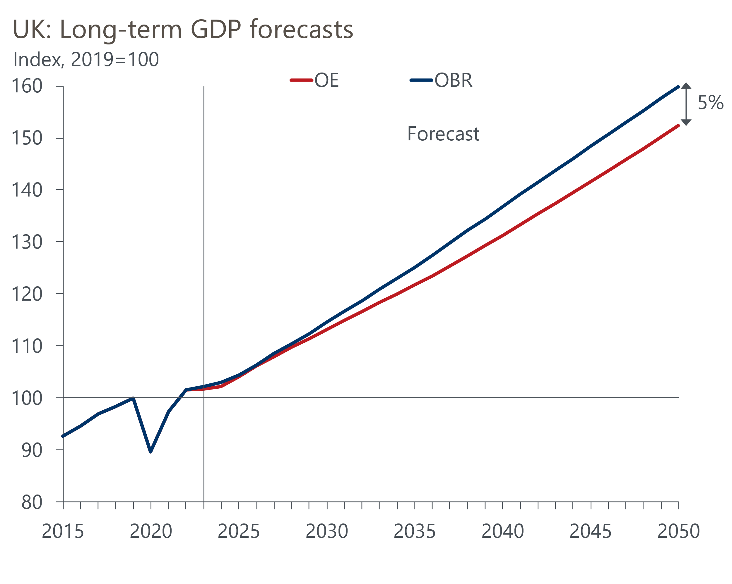
Sources: Oxford Economics, Haver Analytics, OBR

A coherent long-term strategy could make a tangible difference
The chances of achieving the OBR's forecast would be enhanced if the UK had a strategy for improving potential output growth. A year ago, we published a seven point plan for growth, but little progress has been made since then. While the government delivered on most of the recommendations we made for reforming childcare in the March 2023 Budget, there's scant evidence of movement on the remaining six proposals.
It appears unlikely that the government will make much progress in the forthcoming Budget either, with the focus seeming to be on finding space for vote-winning tax cuts rather than a longer-term strategy. And while Labour has correctly identified the importance of planning reform and housebuilding, many governments and opposition parties have proposed structural reforms in this area but have struggled to deliver them because they've not had detailed and coherent implementation plans.
In the absence of substantive policy proposals from either party, we will publish a report after the Budget that will present our take on the optimal approach to fiscal policy, balancing the trade-off between boosting a stagnant economy and the need for fiscal consolidation. We plan to use our Global Economic Model to quantify the impact of better policymaking on potential output and the key fiscal metrics.

Box: A production function approach to estimating potential output
We use a production function approach to estimate potential output. This provides a framework that relates the level of potential output to contributions from factor inputs – labour, human capital, and capital – and the efficiency with which those inputs are used (‘total factor productivity’).
It also provides a consistent method for forecasting future growth in potential output, taking into account important changes such as demographic trends.
Potential output is calculated as:
ln(Y*) = 0.65ln(L) + 0.3ln(H) + 0.35ln(K) + ln(A)
where:
Y* is potential output;
L is potential labour supply, which is equal to the labour supply at the non-accelerating inflation rate of unemployment (NAIRU) multiplied by average hours worked;
H is human capital, which is defined as the average years of education in the working age population;
K is the capital stock;
A is total factor productivity (TFP).

